# **CLASS PROJECT DESIGNING A COUNTERWEIGHT TREBUCHET**

**School of Science and Technology**

**OENG1205 - Creative Engineering CAD**

**Lecturer:** Nguyen Chi Trung

**Tutorial Section:** 5 (10:30 - 12:00)

**Submission Due Date:** 26th December by 23:59

**Group Name:** CAD

**Date:** 26/12/2020

**Student member:**

* Student 1: Truong Tan Gia Huy - s3806881
* Student 2: Thieu Tran Tri Thuc - s3870730
* Student 3: Dang Ngoc Lan - s3878178
* Student 4: Vo Phuc Duy Nhat - s3868763
* Student 5: Nguyen Ngoc Minh Quang - s3836412

**TABLE OF CONTENT**

1. **PROJECT DEFINITION AND AIM………………..…...2**
2. **Trebuchet’s Background…………...……………….2**
3. **Project Objectives and Specifications……………....2**
4. **DESIGN THEORY AND METHODOLOGY…………..2**
5. **DESIGN MECHANISM AND CALCULATION…..…...4**
6. **Overall Detail of Trebuchet……………..………......4**
7. **Calculation……………………………………….......5**
8. **DEVICE DESCRIPTION………………………………...7**
9. **List of Components………………………………….7**
10. **Trebuchet Assembly………………………………..14**
11. **REFERENCES…………………………………….…..…15**
12. **APPENDIX…………………………………………...…..15**
13. **PROJECT DEFINITION AND AIM**

**1. Trebuchet’s Background:**

In the 4th century BC, the catapult appeared as a tool to serve the war against foreign invaders, the catapult was considered a famous siege tool at that time because of its ability to throw large rocks to attack protective fences, large structures as well as fortifications over long distances. There are many different types of catapults and the most famous and used is Trebuchet. Trebuchet is divided into two main categories: Chinese Traction Trebuchet and European Counterweight Trebuchet. The Trebuchet machine was created based on advanced knowledge related to gravity, potential energy, circular motion, horizontal motion, and acceleration. All those laws are important knowledge and concepts that contribute to this Trebuchet. [1]

In this project, all team members will discover how Trebuchet works as well as the ingredients related to this Trebuchet. Team members will apply knowledge from CAD courses such as the use of SolidWorks and computational engineering as well as basic and advanced physics pieces of knowledge related to the Trebuchet to fabricate into one completed simulation product and work most smoothly.

**2. Project Objectives and Specifications:**

The way the Trebuchet works is based on the counterweight and the force of gravity being applied to it. When placing a hook mass (counterweight) on one end of the arm and releasing it, then allowing the string to throw the projectile in a horizontal direction. Then there will be a gravitational force acting on the hook mass (counterweight) that rotates the arm and allows the projectile to be launched away from the string. The more the counterweight increases, the farther the projectile will be launched. The Trebuchet blueprint includes 11 parts to construct a complete Trebuchet: Main Base, two Pivots, Short Arm, Connector, Counterweight Box, First half and second half of Trebuchet's Long Arm, Hook, Extra Base, Pivot Supporter, and Angle Adjusting Block. Each part fits within 14x14x14 cm specifications for 3D printing and 15x15x15 cm for Laser cutting. The Trebuchet has four main components: Pivots, Short Arm, Connector, and Counterweight which will withstand the most force effect on them and are 3D printed using Tough Material. The rest of the Trebuchet parts are made of Non-Translucent Acrylic material enough to meet the needs needed to be able to withstand the forces and to meet the elements needed to be able to throw the projectile away: The first half and second half of the Long arm have a thickness of 0.3cm and the counterweight has enough space to carry two 500g PASCO hooked masses. Theoretically, the Trebuchet remains stable during the projectile firing process because the Trebuchet design elements meet the criteria to help support the features as well as help the Trebuchet work in the best way (legs at the bottom of the Base, extended features of the Pivots for stabilization). [1]

1. **DESIGN THEORY AND METHODOLOGY**

Firstly, the motion of the system (long arm and short arm) is considered as the leverage - the specific situation of moments or torque which can be determined by this equation:

Mclockwise – Mcounterclockwise

where A is the total moment of force that makes the system rotates in the clockwise direction, B is the total moment of force making the system rotate in the counterclockwise direction.

In the clockwise direction, there are two forces exerted on the short arm: the weight of mass and the weight of the short arm, but we can ignore the small weight of the short arm. Then, the clockwise moment is calculated by the formula:

Mclockwise = W

where d is the perpendicular distance between the force and the fulcrum, is

the weight of masses that calculated by the equation:

W = m

In the counterclockwise direction, the moment is created only by the weight of the long arm:

Mcounterclockwise = mlongarm g

As the long arm rotates clockwise, it transmits the centripetal force by the string's tension. Due to centripetal acceleration, the payload will move outwards (at release point) with initial velocity:

FL = T = Fc= m=> =

In reality, the object (ping pong ball) in flight is influenced by the effects of drag [3]. During the vertical descent, the weight and drag of the ball are opposite direction and equal after the ignorable short time interval from the beginning [3]. Hence, the object will move down with zero acceleration (there is no net force acting on it) and terminal velocity that can be calculated by the equation:

=

where m is the mass of the object, g is gravitational acceleration, is the air density (1.2kg/), is the drag coefficient, A is the cross-sectional area of the ball, and is terminal velocity

Then we find the height and the interval time by the following equation [3]:

=ln()

=()

where is the initial vertical velocity of the object that determines by the equation:

= Sin

The interval time object needs to move from the highest point () to the trebuchet's base is calculated by the formula:

=

On the horizontal axis, the total distance of the object is calculated by the equation:

x=ln()

where is the initial horizontal velocity that determines the equation:

= Cos

and t is the total time of the motion (t = +)

1. **DESIGN MECHANISM AND CALCULATION**
2. **Overall Detail of Trebuchet:**

**Introduction**

The Trebuchet is a tool that uses a lever for its throw arm and is also designed and attached to a fixed and solid base. When Trebuchet fires projectiles (these are usually in a rope hanging at one end of the throwing arm) by rotating the arm at a certain speed along its axis. In the Trebuchet construction, the suspension cord is attached to the longer end of the arm and opposite to where the force is applied at the lever's fulcrum, from which the Trebuchet uses the lever to exert a force (also known as a mechanical advantage) throws the projectile in a straight-line direction.

The main composition of the Trebuchet parts is mostly used Tough and Acrylic Material with a shiny finish. The structural components are of equal size and distance, surrounding the cylinder, starting from one end.

The Trebuchet consists of 11 separate parts: Main Base, two Pivots, Short Arm, Connector, Counterweight, First half and Second half of Long Arm, Hook, Extra Base and Angle Adjusting Block.

**Discussion**

*Technical definition:*

Main base: a foundation to carry every part of the trebuchet.

Pivot: the component where the arm connects to the frame of the trebuchet, and the point about which the arm rotates.

Long Arm (divided into First half and Second half): the long component of the arm which is the section that goes from the pivot point to the end where the sling attaches to the arm

Counterweight: is where the hook mass is hung on

Extra base: It is another foundation connect with the main base and the hook

Short Arm: the short component which is the section that goes from the pivot to the end where the weight attaches to.

Connector: the connection part of the Short Arm and Pivot.

Hook: The hook is the firing-range adjusting part.

Angle Adjusting Block: The block is a rectangular help to change the release angle.

*Function and needed theory:*

Main base: The main base is a foundation to assemble every part of the trebuchet together, make it stable during the process, and help to change the release angle by putting a block in several holes in the base body.

Pivot: Two pivots help to increase the height of the trebuchet and allow the connector part to turn around in the hole.

The first half of Long Arm: The role of this part is to combine the second half with the short arm and increase the length of the Long Arm.

The second half of Long Arm: Sticking together with the first half, at the end of this part, a finger is created to hold the string and the ball. [2]

Counterweight: It helps to hang two weights on to provide energy to release the ball.

Extra base: Increase the length of the foundation to put on the ball to release.

Short Arm: The short arm is used to carry weights and counterweight at the end of the long arm.

Connector: The role of this connector is to carry all the weight of the arm, weight, counterweight. Keep its stick together and turn around to release the payload.

Hook: Instead of holding the trebuchet by hand, a hook is created to hold the trebuchet before launching with a rope or a rubber band, so it helps to reduce the accident rate.

Angle Adjusting Block: The function of the block is to help to change the release angle by hindering the counterweight to stop and release the payload.

*_Descript a part in detail:*Mentioned in section ***IV: DEVICE DESCRIPTION.***

**2. Calculation**:

The following calculation using the theory and equations presented in section ***II DESIGN THEORY AND METHODOLOGY.***

Total moment of force make the system rotates in the clockwise direction:

Mclockwise = W= 1x9.8 x 0.115xcos() = 0.6919 (N.m)

Total moment of force make the system rotates in the counterclockwise direction:

Mcounterclockwise = mlongarm g= 0.02 x 9.8 x x cos() = 0.0168 (N.m)

Total moment of two arms:

Mclockwise – Mcounterclockwise = 0.6919 - 0.0168 = 0.6751 (N.m)

Force created by the torque of long arm:

0.6751 0.285 = 2.3688 (N)

Release velocity:

Terminal velocity:

== 7.68 (m/s)

The highest point objects reach and interval time:

=ln() = 2.85 (m)

=() = 0.704 (s)

The interval time the objects reach the base-height:

= = = 0.466 (s)

Distance the objects moved:

x=ln() = 7.366 (m)

To change the release angle, we created 3 holes to block the trebuchet's swing arm every time we launch. Corresponding to each hole will be a different shot angle: (38,45,52) degrees. However, this is only a hypothesis based on calculations and may not be correct because of external influencing factors.

**Conclusion**

A Trebuchet is a throwing machine whose way of working by relying on the energy of counterweights and hinges to throw an object with payload and to use the advantage of science to be able to throw an object with a payload in the shortest possible way with the fastest speed. The trebuchet is made up of parts such as the base, shaft, short arm, connector, sub-base, hook, angle adjustment block, shaft bracket, the first and second long arm of the trebuchet. And then all the parts come together as Trebuchet are like those in ancient but more modern machines.

1. **DEVICE DESCRIPTION**
2. **Lists of Components:**

The Trebuchet includes a total of 11 parts: Main Base, two Pivots, Short Arm, Counterweight, Connector, First half and Second half of Long Arm, Extra Base, Hook, Angle Adjusting Block. There are also a few external strings for holding and firing the ball. The table below will show each component in detail:

|  |  |  |  |
| --- | --- | --- | --- |
| **Part No.** | **Part Name, Description** | **Bill of Material** | **Manufacturing Method** |
| 1 | **Main Base (Quantity: 1)**    The Main Base of the Trebuchet where every part is attached above, with a platform isolated from the ground to place the ball before being fired. There are four rectangular holes at the side for firing angle adjusting purposes; 2 rectangular holes on the top to attach the Pivots. | Non-Translucent Acrylic | Laser Cut |
| 2 | **Pivot (Quantity: 2)**    The Pivot is the frame of the Trebuchet to connect to the Arms. There are three cubic triangles at the bottom of the Pivot for stabilization, keeping the Pivot stay vertically with the ground while withstanding such weight. The 0.75cm diameter hole is designed to be a little bigger than the Connector 1 to reduce assembling risk based on the Part tolerance. | Non-Translucent Acrylic | Laser Cut |
| 3 | **Short Arm (Quantity: 1)**    The Short Arm has holes at two sides: one side connects to the Shaft of the Pivot while the other side connects to the Counterweight part. There is a rectangular hole at the end to connect to the Long Arm of the Trebuchet. | Tough 2000 Resin | 3D Print |
| 4 | **Connector 1 (Quantity: 1)**    The Connector 1 is the part to connect the Short Arm and The Pivots and it will be glued to the Pivots to remain fixed. | Tough 2000 Resin | 3D Print |
| 5 | **Counterweight (Quantity: 1)**    The Counterweight is the part connected to the Short Arm - which will be the part to hang the PASCO Hooked Mass on. | Tough 2000 Resin | 3D Print |
| 6 | **The first half of Long Arm (Quantity: 1)**    The first half of Long Arm is connected through the rectangular hole of the Short Arm. | Non-Translucent Acrylic | Laser Cut |
| 7 | **The second half of Long Arm (Quantity: 1)**    The second half of Long Arm is connected serially with the first half part and the Sling of the Trebuchet to fire a ball. There are two holes at the end to put the strings through (one string of the Sling and one string for firing range adjustment); a finger at the tip of the Arm to release the Sling at an angle. | Non-Translucent Acrylic | Laser Cut |
| 8 | **Hook (Quantity: 1)**  The Hook is an extra part for firing range adjustment which will hold the string from the Short Arm before firing. | Non-Translucent Acrylic | Laser Cut |
| 9 | **Extra Base (Quantity: 1)**    The Extra Base is connected serially next to the Main Base to provide a platform for the ball to stay on that is long enough to reduce any risk during the firing process. | Non-Translucent Acrylic | Laser Cut |
| 10 | **Angle Adjusting Block**    The Angle Adjusting Block is an extra part to put into one of the 4 rectangular holes on the Main Base to adjust the firing angle of the Trebuchet. | Non-Translucent Acrylic | Laser Cut |
| 11 | **Strings (Quantity: more than 3)**  Two strings (28cm each) to connect the Ball Holder and the Long Arm.  One or more strings at different lengths to connect the Long Arm and the Hook for firing-range adjustment. | Cotton | Handmade |
| 12 | **Ball Holder (Quantity: 1)**  The Ball Holder is a 5x5cm piece of cloth to hold the table tennis ball, with two holes on two sides to connect with the strings. | Cloth | Handmade |

**2. Trebuchet Assembly:**

The video shows the assembling process is in this link: <https://drive.google.com/file/d/1iGKMvutMxEUZ5X3pgqTnK1L0Iz63H6B5/view?usp=sharing>

Assembling instruction (every part is glued together using a glue gun):

* Place the Main Base on a horizontal surface, then attach the two Pivots into the rectangular holes on top of the Main Base with the cubic triangle feature facing towards each other.
* Put the Connector through the hole on one side of the Short Arm (with the CAD logo notched above) until the cone shape of the Connector touches the Short Arm, then attach the Connector through two holes of the Pivots, connect the Counterweight part to the other side of the Short Arm. Next, adjust the position of the combination above (Connector, Short Arm and Counterweight) so that none of them touches the Main Base or Pivots when rotating. The Connector should be fixed to the Pivots, the Counterweight should be fixed to the Short Arm. Finally, create a little knot made of glue next to the Short Arm so that the Short Arm stays between the cone shape of the Connector and that knot so the total space between them is within 5mm so that the Short Arm stays in the middle of the Trebuchet.
* Put the First half of Long Arm through the rectangular hole of the Short Arm, continue with the Second half of Long Arm connecting serially with the First half part. Both parts are connected with the CAD logo face upward.
* Attach the Extra Base next to one side of the Main Base (the side below the Long Arm) so that both parts’ platforms are horizontal, and the tiny hole of the Extra Base is exposed. Lastly, put the Hook into the tiny hole of the Extra Base.
* There will be three types of strings: one will be used to hold the Long Arm with the Hook by making one side a knot, the other is a loop (the knot side will be fixed with two holes in the long arm and the loop side will keep with the hook). About the two other strings: one will connect with one end of the ball holder and a finger in the Long Arm. Another will stick with the Long Arm and the other side of the ball holder. The ball will be placed on the platform of the Main Base.

The Trebuchet should look like the one in the video below when it is correctly assembled: <https://drive.google.com/file/d/18oVofkFv9a6Sbcly3jYNR8SaLRhRYL2h/view?usp=sharing>

1. **REFERENCES**

[1] *OENG1205 - Project Description (Sem 3 - 2020)*, RMIT University Vietnam, Saigon South Campus. Assessed on: Dec. 26, 2020. [Online]. Available:

[https://rmit.instructure.com/courses/82916/files/15760880/download\](https://rmit.instructure.com/courses/82916/files/15760880/download%5C)

[2] F. Normani. “Trebuchet Physics”, real-world-physics-problems.com.

<https://www.real-world-physics-problems.com/trebuchet-physics.html> (accessed Dec. 17,2020).

[3] N. Hall. “Flight Equations with Drag (no thrust - constant mass)”, nasa.gov.

<https://www.grc.nasa.gov/www/k-12/airplane/flteqs.html?fbclid=IwAR0y2K-beFHgFStTFPZGkk1vCNCY7zUO2gUAXBcESJvDFs17MUg4kul34jk> (accessed Dec. 17,2020).

1. **APPENDIX**

**Engineering drawings for the components:**

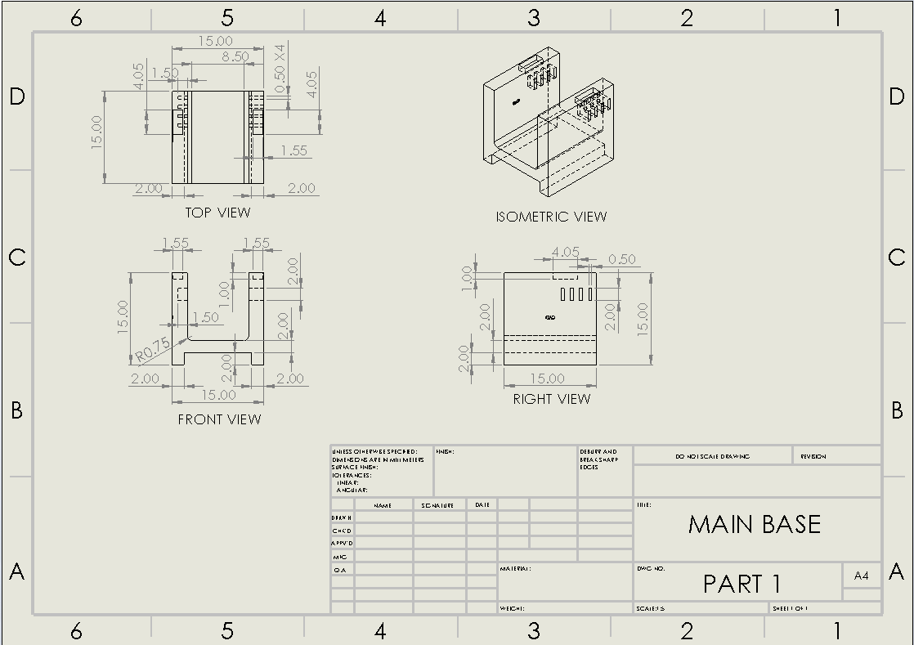

**Figure 1:** Part 1 (Main Base) Drawing

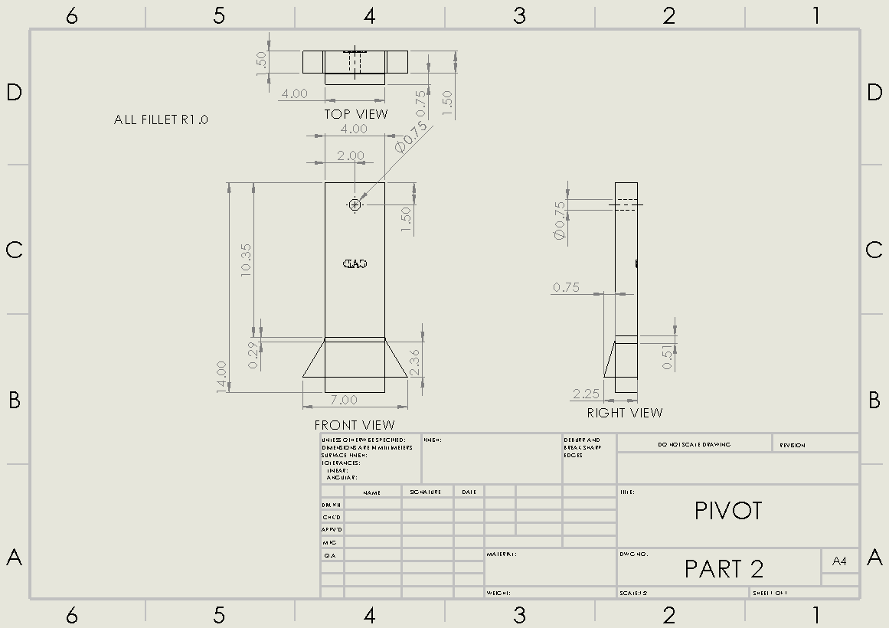

**Figure 2:** Part 2 (Pivot) Drawing

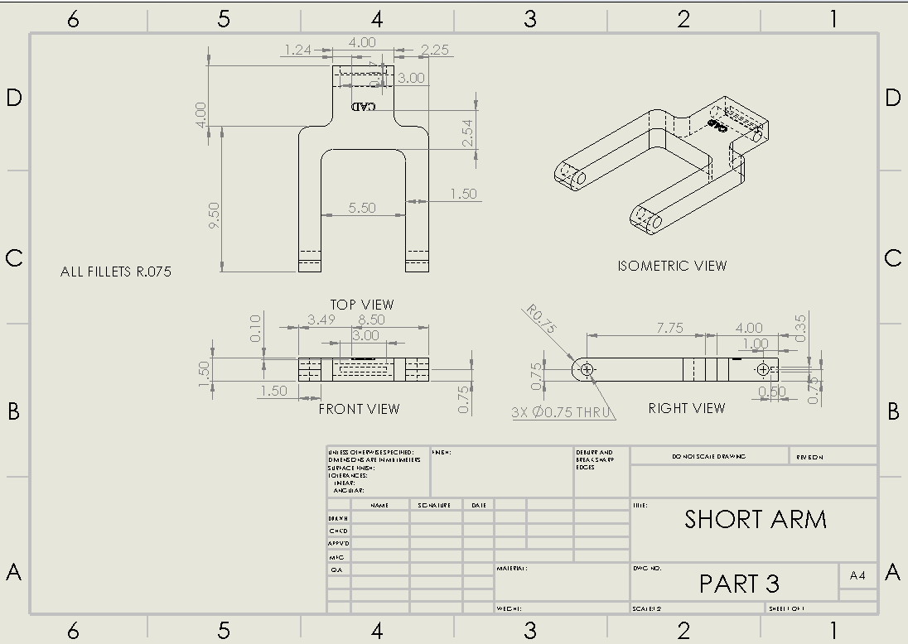

**Figure 3:** Part 3 (Short Arm) Drawing

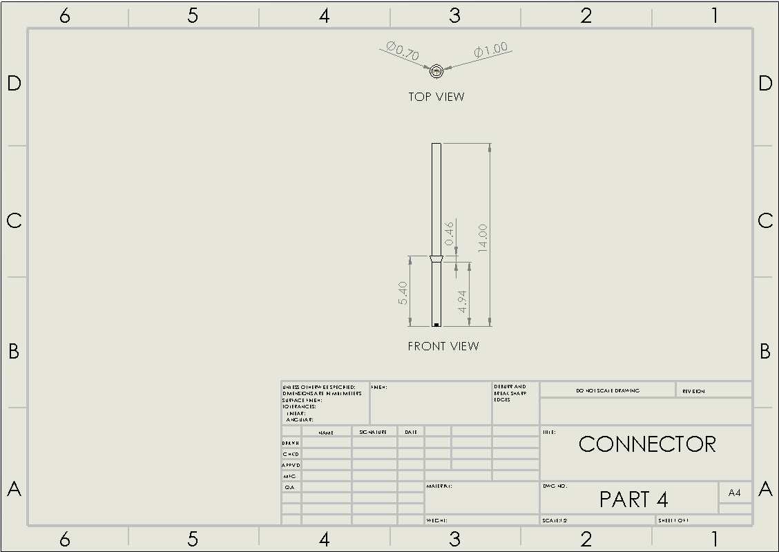

**Figure 4:** Part 4 (Connector) Drawing

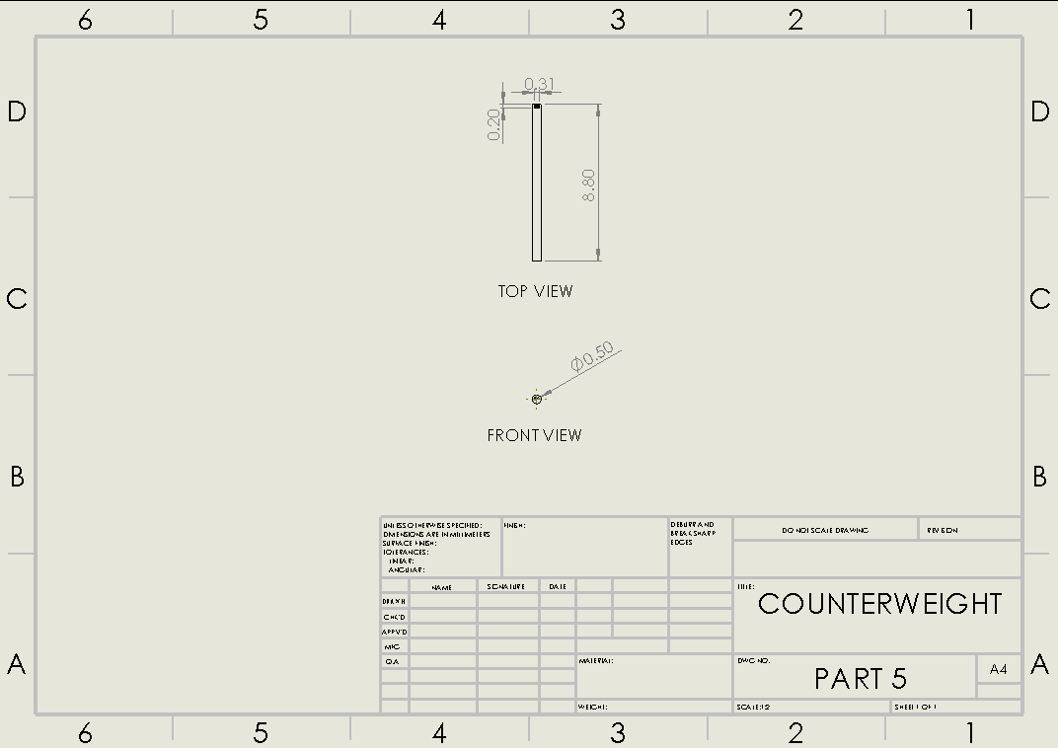

**Figure 5:** Part 5 (Counterweight) Drawing

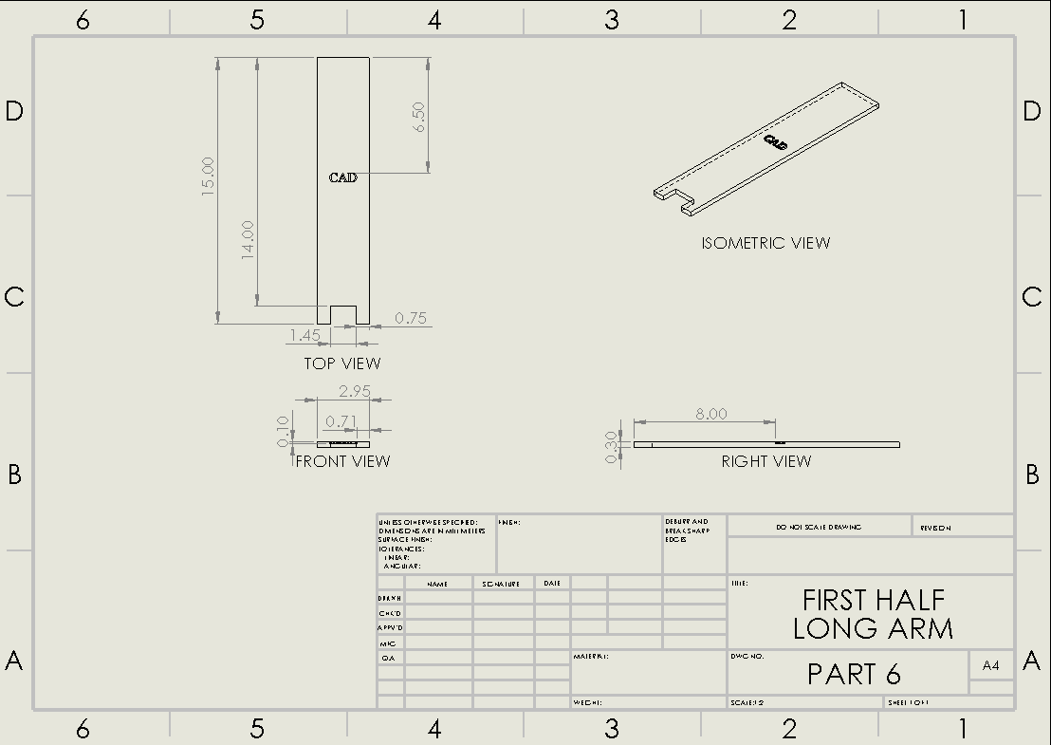

**Figure 6:** Part 6 (First half of Long Arm) Drawing

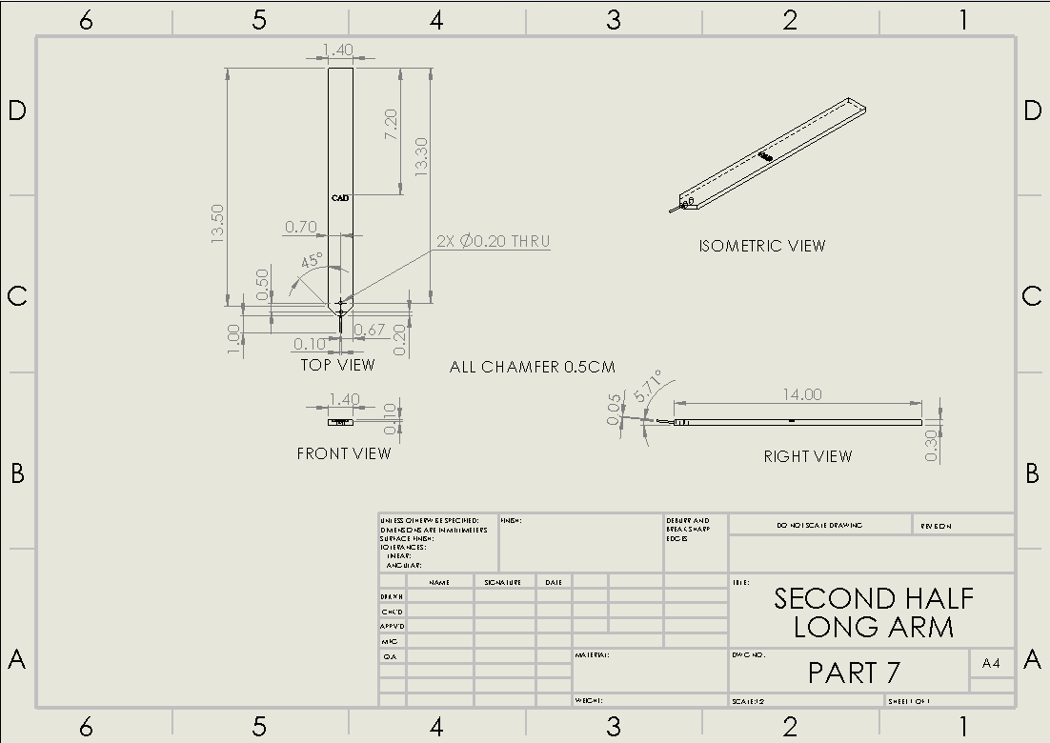

**Figure 7:** Part 7 (Second half of Long Arm) Drawing

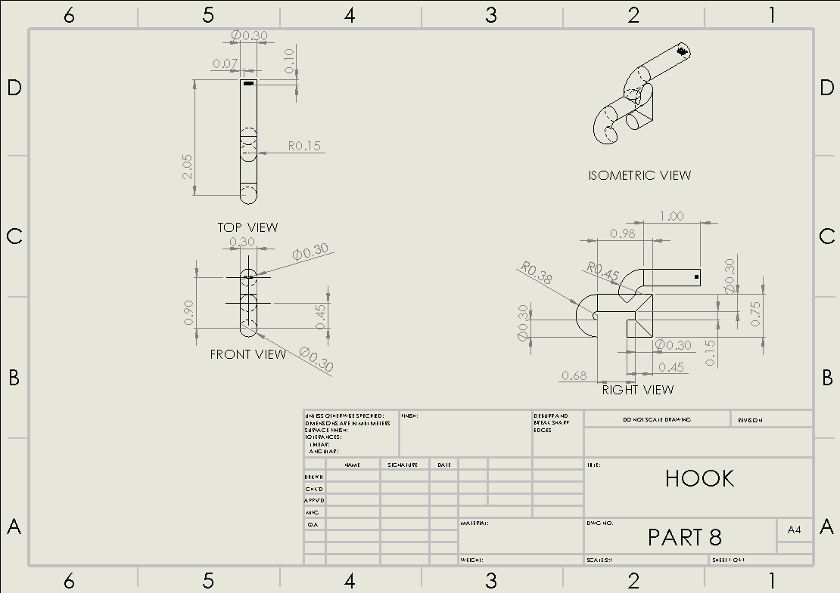

**Figure 8:** Part 8 (Hook) Drawing

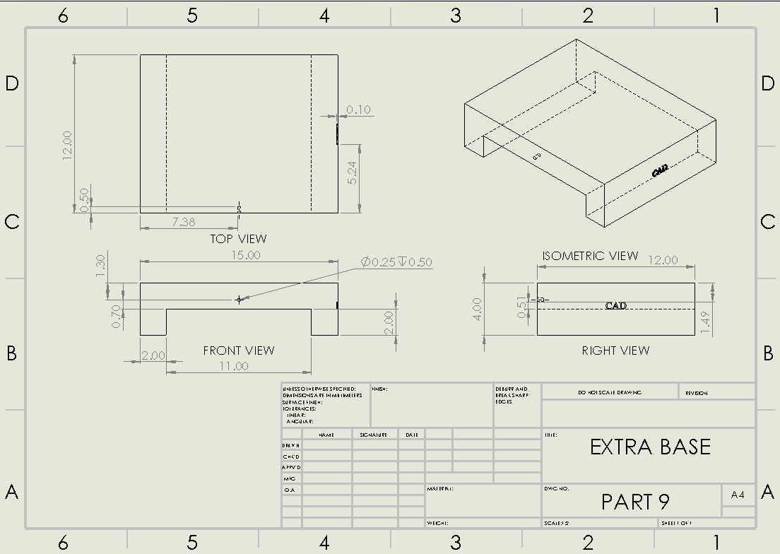

**Figure 9:** Part 9 (Extra Base) Drawing

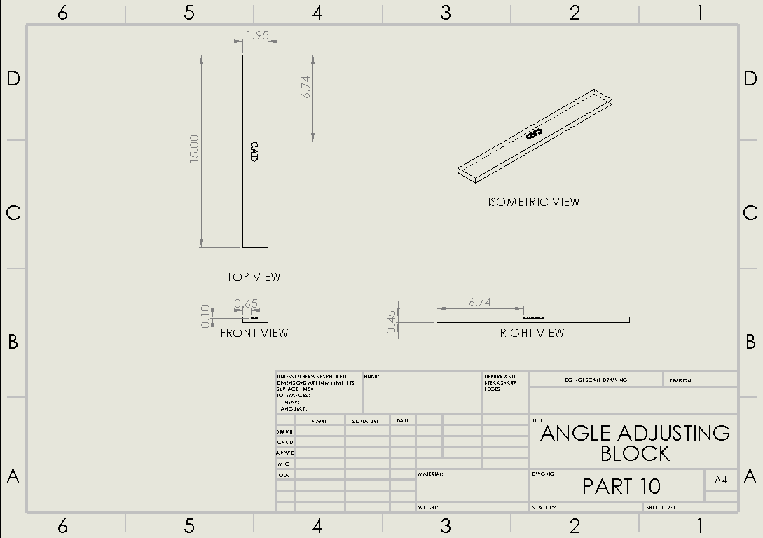

**Figure 10:** Part 10 (Angle Adjusting Block) Drawing